Detecting Compromised Host on Security Onion

As part of my ongoing cyber defense and threat detection lab at codeessence, I investigated brute force attemtp on security onion using zeek, kibana, and suricata.

Scenario 9 — Compromised Host Investigation

Investigation Summary
During the analysis, several alerts were detected in Security Onion indicating a possible phishing or malware infection on a host system. Key alerts included:
- Cobalt Strike Beacon Observed — evidence of potential command-and-control (C2) activity.
- Hancitor Checkin and Metasploit Payload Detected — confirming malicious code execution and persistence attempts.
- External IP Lookup events — showing possible data exfiltration or remote access communication.

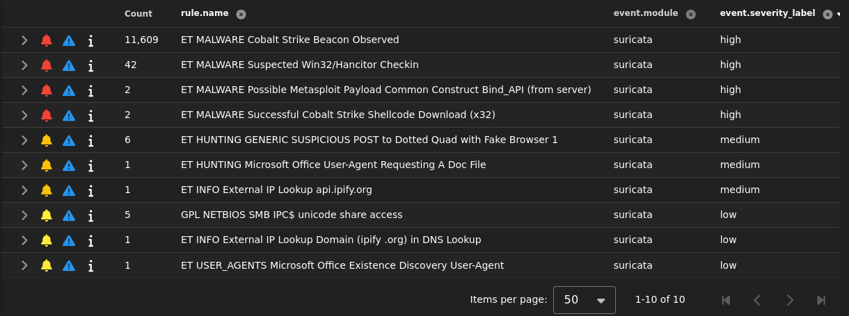

Analysis
- These events strongly suggest a phishing-based malware compromise, where the user may have executed a malicious attachment or link.
- The infected endpoint initiated C2 connections to external servers, consistent with post-exploitation behavior.
- Correlation with Zeek and Suricata logs showed repeated outbound connections to suspicious IPs, supporting the malware activity hypothesis.
Conclusion
The host exhibited clear indicators of compromise (IOC) consistent with malware infection and remote control. The incident demonstrates the analyst’s ability to:
1. Identify and interpret phishing and C2 indicators from Security Onion alerts.
2. Correlate endpoint and network data to confirm compromise and assess impact.

Tools Used:
Security Onion, Zeek, Suricata, Kibana
Tags:
#CyberSecurity #ThreatDetection #host-compromise #WebSecurity #SecurityOnion #Zeek #Suricata #DVWA #BlueTeam

